Workflow of LINUX Task 1:-

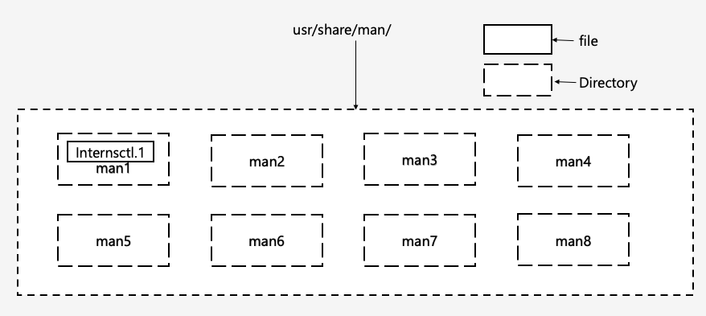

Script Setup

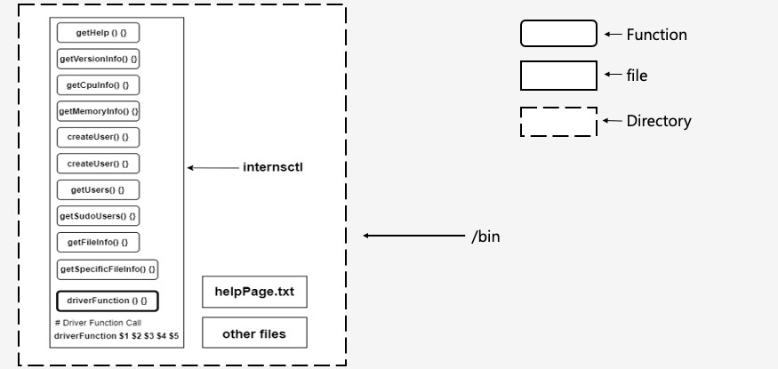

Creating and Configuring the Custom Command : internsctl

Section A

## Creating manual (man) page**

#### Step 1 :

##### Login as a root user by running the command sudo -i (If it asks for the administrative password, Enter it).

* + - Now using cd command move into to the standrad location in filesystem

: /usr/share/man, where manual pages of all the commands are normally stored in **nroff(1)** format.

##### Then run ls command to list all the directories in that location.

Here in this location, each man page is categorized in a specific section (directory), different directories (e.g., man1, man2, man3...) store man pages for different category of commands. See below -

man1 - User Commands man2 - System Calls

man3 - C Library Functions

man4 - Devices and Special Files man5 - File Formats and Conventions man6 - Games et. al

man7 - Miscellaneous

man8 - System Administration tools and Daemons

Now since **internsctl** is a **user command**, we will create and store the manual page file in /man1 directory.

#### Step 2 :

##### From the current directory, navigate to /man1 directory using cd man1 command.

* + - Create the source file of the man page using the command touch followed by <File_Name>.<Section_Index>.

##### File_Name : The command whose manual page to be created.

Section_Index : For man1 - it'll be **1**, For man2 - it'll be **2**, and so on.

In this case it will be : **touch internsctl.1**

#### Step 3 :

##### Now run nano internsctl.1 to edit the source file in nano text editor. Copy and paste the following script into the source file or write it from yourself and save it.

* + - .\" Manual (man) page of internsctl
    - .TH internsctl 1 "10 june 2023" "0.1.0" "Custom Command"
    - .SH NAME
    - internsctl
    - .SH SYNOPSIS
    - internsctl cpu getinfo |
    - .brinternsctl memory getinfo |
    - .brinternsctl user create <username> |
    - internsctl user list |
    - internsctl user list --sudo-only |
    - internsctl file getinfo <file-name> |
    - internsctl file getinfo [options] <file-name>
    - .SH DESCRIPTION
    - Display cpu and memory information, create new user, list all users, list all users with sudo permissions, get file information, get specific information of file.
    - .SH OPTIONS
    - .TP
    - .BR \-\-size ", " \-s print " " file " " size
    - .TP
    - .BR \-\-permissions ", " \-p print " " file " " permissions
    - .TP
    - .BR \-\-owner ", " \-o print " " file " " owner
    - .TP
    - .BR \-\-last-modified ", " \-m print " " last " " modified " " date " " and " " time " " of " " the " " file
    - .SH BUGS
    - No known bugs.
    - .SH AUTHOR
    - SAMRIDHI VERMA

#### Step 4 :

* + - Run man internsctl from terminal to check the manual page of the internsctl.
    - 2. Creating function to display the help text through the command internsctl --help**
  + Create a file internsctl in /bin directory.

##### Copy and paste the following code into that file and save it.

* + getHelp () {
  + cat /usr/bin/helpPage.txt
  + }

##### Now create another file helpPage.txt in the same directory and copy and paste the following help text into that file and save it.

* + Usage: 'internsctl cpu getinfo' -> Get cpu information of the local server.
  + 'internsctl memory getinfo' -> Get memory information of the local server.
  + 'internsctl user create <username>' -> Create a new user on

the local server.

* + 'internsctl user list' -> List all the regular users present on the local server.
  + 'internsctl user list' --sudo-only' -> List all the users with sudo permissions on the local server.
  + 'internsctl file getinfo <file-name>' -> Get information about a file.
  + 'internsctl file getinfo [options] <file-name>' -> Get specific information about a file.

•

* + Mandatory arguments to long options are mandatory for short options too.
  + --size, -s print file size
  + --permissions, -p print file permissions
  + --owner, -o print file owner
  + --last-modified, -m print last modified date and time of the file

•

* + --help display help text and exit
  + --version output version information and exit

•

* + Exit status:
  + 0 if OK,
  + 1 if minor problems (e.g., cannot access subdirectory),
  + 2 if serious trouble (e.g., cannot access command-line argument).

1. Creating function to display version of the command through internsctl -- version**

##### Add the following code into the file internsctl present in /bin folder and save it.

* + getVersionInfo () {
  + echo "internsctl 0.1.0"
  + echo "Copyright (C) 2024 XenonStack "
  + }

# Section B

### Part 1 | Level Easy

1. Creating function to get cpu information of server through the command internsctl cpu getinfo**

##### Add the following code into the file internsctl present in /bin folder and save it.

* + getCpuInfo () {
  + lscpu
  + }

•

1. Creating function to get memory information of server through the command internsctl memory getinfo**

##### Add the following code into the file internsctl present in /bin folder and save it.

* + getMemoryInfo () {
  + free
  + }

### Part 2 | Level Intermediate

1. Creating function to create a new user on server through the command internsctl user create <username>**

##### Add the following code into the file internsctl present in /bin folder and save it.

* createUser () {
* sudo adduser $3
* }

1. Creating function to list all the regular users present on the server through the command internsctl user list**

##### Add the following code into the file internsctl present in /bin folder and save it.

* + getUsers () {
  + cut -d: -f1 /etc/passwd
  + }

1. Creating function to list all the users with sudo permissions on the server through the command internsctl user list --sudo-only**

##### Add the following code into the file internsctl present in /bin folder and save it.

* + getSudoUsers () {
  + getent group sudo | cut -d: -f4
  + }

*Part 3 | Advanced Level*

1. Creating function to get some information about a file through the command internsctl file getinfo <file-name>**

##### Add the following code into the file internsctl present in /bin folder and save it.

* + getFileInfo () {
  + if test -f "$3"; then
  + echo "File: $3"
  + displayPermissions() {
  + case "$1" in
  + 0) echo "no";;
  + 1) echo "--x";;
  + 2) echo "-w-";;
  + 3) echo "-wx";;
  + 4) echo "r--";;
  + 5) echo "r-x";;
  + 6) echo "rw-";;
  + 7) echo "rwx";;
  + esac
  + }
  + permissions=$(stat -c%a "$3")
  + user=${permissions:0:1}
  + group=${permissions:1:1}
  + others=${permissions:2:1}
  + echo "Access: -$(displayPermissions $user)$(displayPermissions

$group)$(displayPermissions $others)"

* + myFileSize=$(wc -c $3 | awk '{print $1}')
  + echo "Size(B): $myFileSize"
  + echo "Owner: $(stat -c '%U' $3)"
  + else
  + echo "internsctl: cannot access '$3': No such file in current directory"
  + fi
  + }

1. Creating function to get specific information about a file through the command internsctl file getinfo [options] <file-name>**

##### Add the following code into the file internsctl present in /bin folder and save it.

* + getSpecificFileInfo () {
  + case "$3" in
  + --size | -s)
  + if test -f "$4"; then
  + myFileSize=$(wc -c $4 | awk '{print $1}')
  + if [ $myFileSize -ge 1000 ]; then
  + myFileSize=$(echo "$myFileSize *

0.001"|bc)

* + printf "%.2f kilobytes\n"

|  |  |  |  |  |  |
| --- | --- | --- | --- | --- | --- |
| $myFileSize |  |  |  |  | |
| • |  | else |  |
| • |  |  | echo "$myFileSize bytes" |
| • |  | fi |  |  |  |
| • | else |  |  |  |  |
| • |  | echo | "internsctl: cannot access | '$4': | No |

|  |  |
| --- | --- |
|  | such file in current directory" |
| • | fi ;; |
| • |  |
| • | "--permissions" | "-p") |
| • | if test -f "$4"; then |
| • | displayPermissions() { |
| • | case "$1" in |
| • | 0) echo "no";; |
| • | 1) echo "--x";; |
| • | 2) echo "-w-";; |
| • | 3) echo "-wx";; |
| • | 4) echo "r--";; |
| • | 5) echo "r-x";; |
| • | 6) echo "rw-";; |
| • | 7) echo "rwx";; |
| • | esac |
| • | } |
| • | permissions=$(stat -c%a "$4") |
| • | user=${permissions:0:1} |
| • | group=${permissions:1:1} |
| • | others=${permissions:2:1} |
| • | echo "-$(displayPermissions |
|  | $user)$(displayPermissions $group)$(displayPermissions $others)" |
| • | else |
| • | echo "internsctl: cannot access '$4': No |

such file in current directory"

* + fi ;;

•

* + "--owner" | "-o")
  + if test -f "$4"; then
  + echo "$(stat -c '%U' $4)"
  + else
  + echo "internsctl: cannot access '$4': No such file in current directory"
  + fi ;;

•

* + "--last-modified" | "-m")
  + if test -f "$4"; then
  + echo "$(stat -c '%y' $4)"
  + else
  + echo "internsctl: cannot access '$4': No such file in current directory"
  + fi ;;

•

* + *)
  + if [ "${3:0:1}" = "-" ]; then
  + echo "internsctl: invalid option"
  + printf "\nUsage:\n internsctl file getinfo [options] <file-name>\n"
  + printf "\nTry 'internsctl --help' for more

information.\n"

* + else
  + printf "error: too many arguments\n"
  + printf "\nUsage:\n internsctl file getinfo

<file-name>\n"

* + printf "\n Try 'internsctl --help' for additional help text.\n"
  + fi ;;
  + esac
  + }

**Options :**

##### --size, -s to print size

--permissions, -p to print file permissions

##### --owner, -o toprint file owner

--last-modified, -m to print last modification time and date